Definitions
- Cycle Time:
Cycle time describes, how long it takes to complete a specific task from start to finish.
It can also be define as;
The period required to complete one cycle of an operation, or to complete a function,job or task from start to finish.
Cycle time is used in differentiating total duration of a process from its run time.
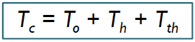
where Tc = cycle time,
To = processing time for the operation,
Th = handling time (e.g.loading and unloading the production machine)
Tth = tool handling time (e.g., time to change tools)
Example:
The cycle time of motors assembled at the rate of 120 per hour would be 30 second per unit.
- Lead Time:
A lead time is the latency between the initiation and execution of a process.
It can also be dine as;
The average time it takes for one unit of the thing being transformed to go through every step of the process (or every process of the entire value stream) from start to finish — including time waiting between steps also known as “Throughput Time”, "Delivery Time", or “Turnaround Time”
Lead Time = Sum of all Process Lead Times + Sum of all Queue Times between processes
Lead Time = Cycle time * WIP
Or
Lead Time = WIP / Throughput
Example:
the lead time between the placement of an order and delivery of a new car from a manufacturer may be anywhere from 2 weeks to 6 months. In industry, lead time reduction is an important part of lean manufacturing.
- Manufacturing Lead Time:
Time from sales order created to production finished (ready for delivery).
It can also be define as;
Total time required to manufacture an item, including order preparation time, queue time, setup time, run time, move time, inspection time, and put-away time.
For make-to-order products, it is the time taken from release of an order to production and shipment.
For make-to-stock products, it is the time taken from the release of an order to production and receipt into finished goods inventory.
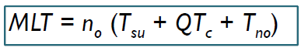
Where MLT = manufacturing lead time,
n_{o}= number of operations,
Tsu = setup time,
Q = batch quantity, Tc cycle time per part,
Tno = non-operation time
Example:
A restaurant opens up and a customer walks in. A waiter guides him to a table, gives him the menu and asks what he would like to order. The customer selects a dish and the waiter writes it in his notepad. At that moment the customer has made an order which the restaurant has accepted - Order Lead Time and Order Handling Time have begun. Now the waiter marks the order in the cash register, rips the paper from the notepad, takes it into the kitchen and puts into the order queue. The order has been handled and is waiting in the factory (kitchen) for manufacturing. As there are no other customers, the waiter decides to stand outside the kitchen, by the door, waiting for the dish to be prepared and begins calculating Manufacturing Lead Time.
- Takt time:
Takt time, derived from the German word Taktzeit, translated best as meter, is the average unit production time needed to meet customer demand.
Assuming a product is made one unit at a time at a constant rate during the net available work time, the takt time is the amount of time that must elapse between two consecutive unit completions in order to meet the demand.
Takt time can be first determined with the formula:
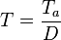
Where
T = Takt time, e.g. [work time between two consecutive units]
T_{a} = Net time available to work, e.g. [work time per period]
D = Demand (customer demand), e.g. [units required per period]
Net available time is the amount of time available for work to be done. This excludes break times and any expected stoppage time (for example scheduled maintenance, team briefings, etc.).
Example:
The customer wants to buy 10 units per week, the average time to build an unit must be 4 hours (or less) if the units are built during a 40 hour work week. Industrial manufacturing lines must have production cycle times at least as short as the takt time so that production can meet the customer demand.
- Throughput time:
Throughput time or cycle time is the amount of time it takes for a manufacturer to make a product. The throughput time of a product is calculated by adding the four steps of the manufacturing process: process time, inspection time, move time, and wait time.
- Production Time:
A machine is running when there is output, regardless of the quantity or quality.
- In manufacturing, the number of goods that can be produced during a given period of time.
Alternatively, the amount of time it takes to produce one unit of a good.
- Production Rate:
In manufacturing,the number of goods that can be produced during a given period of time. Alternatively, the amount of time it takes to produce one unit of a good.
In construction,the rate at which workers are expected to complete a certain segment, such as a road or building. The production rate will depend on the speed at which workers are expected to operate, generally categorized as slow, average or fast.
For manufacturing and construction, a higher production rate can lead to a decrease in quality. As machines or employees work to have more product pushed through the production line or more of a building completed, more mistakes are likely to happen. There is thus a point at which a decrease in quality could wind up costing a company more, even if less time is needed to push out a unit.
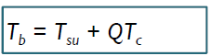
Production rate include;
Batch production: batch time
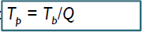
Average production time per work unit
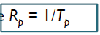
So,
Production rate =
Where,
T_{su} = Setup time
T_{p} = Production time
R_{p} = Production rate
- Quality Assurance and Quality Control:
QA/QC is the combination of quality assurance, the process or set of processes used to measure and assure the quality of a product, andquality control, the process of meeting products and services to consumer expectations. Quality Assurance is process oriented and focuses on defect prevention, while quality control is product oriented and focuses on defect identification.
Comparison is shown below:

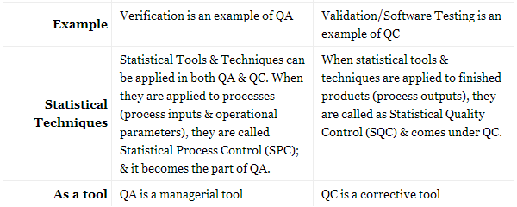
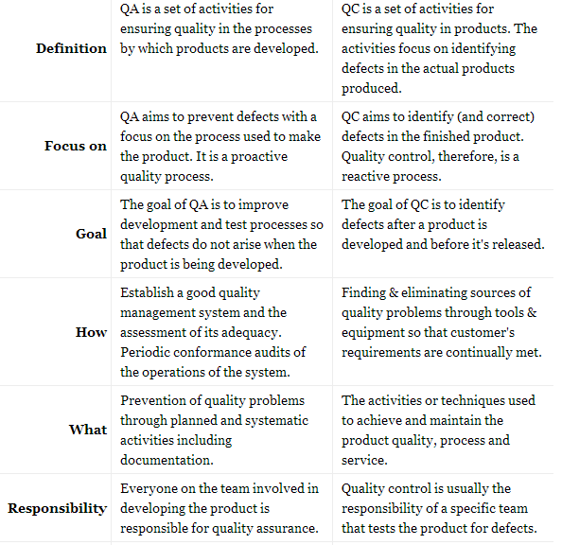
Quality Assurance
Quality Control

